AI Assignment-12

Jeetu Mehra
U24AI032

Question 1 : 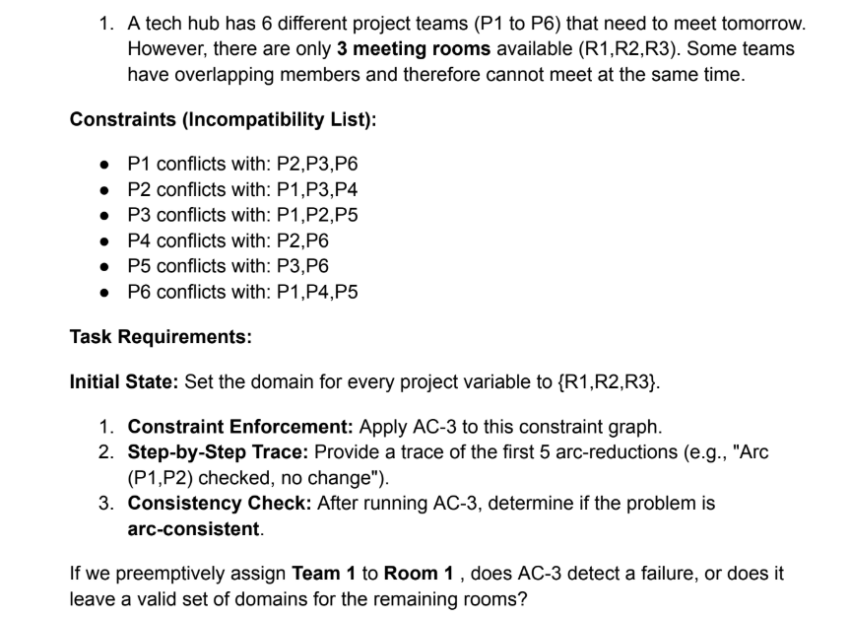
Code:
from collections import deque

# Constraint graph
graph = {
"P1": ["P2", "P3", "P6"],
"P2": ["P1", "P3", "P4"],
"P3": ["P1", "P2", "P5"],
"P4": ["P2", "P6"],
"P5": ["P3", "P6"],
"P6": ["P1", "P4", "P5"]
}

# Initial domains
domains = {
"P1": {"R1", "R2", "R3"},
"P2": {"R1", "R2", "R3"},
"P3": {"R1", "R2", "R3"},
"P4": {"R1", "R2", "R3"},
"P5": {"R1", "R2", "R3"},
"P6": {"R1", "R2", "R3"}
}

# Revise function
def revise(domains, xi, xj):
revised = False
to_remove = set()

for val_i in domains[xi]:
# Check if there exists val_j such that val_i != val_j
if not any(val_i != val_j for val_j in domains[xj]):
to_remove.add(val_i)

if to_remove:
domains[xi] -= to_remove
revised = True

return revised

# AC-3 Algorithm
def ac3(domains, graph, trace=False):
queue = deque()

# Initialize queue with all arcs
for xi in graph:
for xj in graph[xi]:
queue.append((xi, xj))

step = 0

while queue:
xi, xj = queue.popleft()

if trace and step < 5:
print(f"Step {step+1}: Checking arc ({xi}, {xj})")

if revise(domains, xi, xj):
if trace and step < 5:
print(f" Domain revised: {xi} -> {domains[xi]}")

if not domains[xi]:
return False

for neighbor in graph[xi]:
if neighbor != xj:
queue.append((neighbor, xi))
else:
if trace and step < 5:
print(" No change")

step += 1

return True

# Helper function to print domains
def print_domains(domains):
for var in domains:
print(f"{var}: {domains[var]}")
print("-" * 30)

# ------------------ MAIN ------------------

print("Initial Domains:")
print_domains(domains)

print("Running AC-3 (Initial)...")
ac3(domains, graph, trace=True)

print("\nAfter AC-3:")
print_domains(domains)

# Assign P1 = R1
print("\nAssign P1 = R1 and re-run AC-3")
domains["P1"] = {"R1"}

result = ac3(domains, graph)

print("\nAfter Assignment:")
print_domains(domains)

if result:
print("✅ No failure (arc-consistent)")
else:
print("❌ Failure detected (empty domain)")

Question 2 :

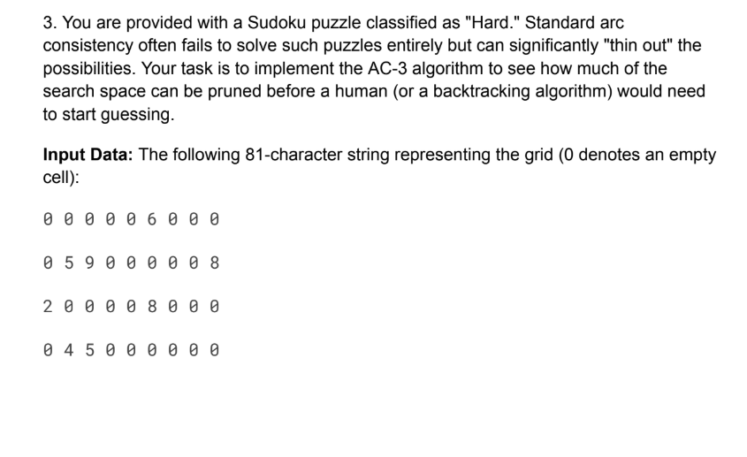Code:
from collections import deque

# ---------------- INPUT GRID ----------------
grid = [
[0,0,0,0,0,6,0,0,0],
[0,5,9,0,0,0,0,0,8],
[2,0,0,0,0,8,0,0,0],
[0,4,5,0,0,0,0,0,0],
[0,0,3,0,0,0,0,0,0],
[0,0,6,0,0,3,0,5,0],
[0,0,0,0,0,7,0,0,0],
[0,0,0,0,0,0,0,0,0],
[0,0,0,0,5,0,0,0,2]
]

# ---------------- SETUP ----------------

# Variables = (row, col)
variables = [(r, c) for r in range(9) for c in range(9)]

# Domains
domains = {}

for r in range(9):
for c in range(9):
if grid[r][c] == 0:
domains[(r,c)] = set(range(1,10))
else:
domains[(r,c)] = {grid[r][c]}

# ---------------- NEIGHBORS ----------------

def get_neighbors(r, c):
neighbors = set()

# Row + Column
for i in range(9):
if i != c:
neighbors.add((r, i))
if i != r:
neighbors.add((i, c))

# 3x3 box
box_r, box_c = 3*(r//3), 3*(c//3)
for i in range(box_r, box_r+3):
for j in range(box_c, box_c+3):
if (i, j) != (r, c):
neighbors.add((i, j))

return neighbors

# Build graph
neighbors = {var: get_neighbors(*var) for var in variables}

# ---------------- AC-3 ----------------

def revise(domains, xi, xj):
revised = False
removed_count = 0

to_remove = set()

for val_i in domains[xi]:
if not any(val_i != val_j for val_j in domains[xj]):
to_remove.add(val_i)

if to_remove:
domains[xi] -= to_remove
revised = True
removed_count = len(to_remove)

return revised, removed_count

def ac3(domains, neighbors):
queue = deque()

# Generate all arcs automatically
for xi in neighbors:
for xj in neighbors[xi]:
queue.append((xi, xj))

total_removed = 0

while queue:
xi, xj = queue.popleft()

revised, removed = revise(domains, xi, xj)

if revised:
total_removed += removed

# If domain empty → failure
if len(domains[xi]) == 0:
return False, total_removed

for xk in neighbors[xi]:
if xk != xj:
queue.append((xk, xi))

return True, total_removed

# ---------------- RUN AC-3 ----------------

result, removed_values = ac3(domains, neighbors)

# ---------------- OUTPUT ----------------

print("Total values removed:", removed_values)

print("\nDomain Size Grid:")
for r in range(9):
for c in range(9):
print(len(domains[(r,c)]), end=" ")
print()

# ---------------- FINAL CHECK ----------------

all_one = all(len(domains[var]) == 1 for var in domains)
any_zero = any(len(domains[var]) == 0 for var in domains)

print("\nFinal Result:")
if any_zero:
print(" Failure: Some domain became EMPTY → Unsolvable")
elif all_one:
print(" Fully Solved by AC-3")
else:
print(" Partially Reduced (Expected for HARD Sudoku)")

